**Question 3: Activity Diagram for adding a comment**

Assumption:

-Dog’s owner already login the AIK9 website , so the activity diagram does not need to have owner’s identity Authentication process.

-Stalled case and Open case always has available vet. In case a Vet  officially resigned, the company always transferred stalled and open case of that vet to another vet

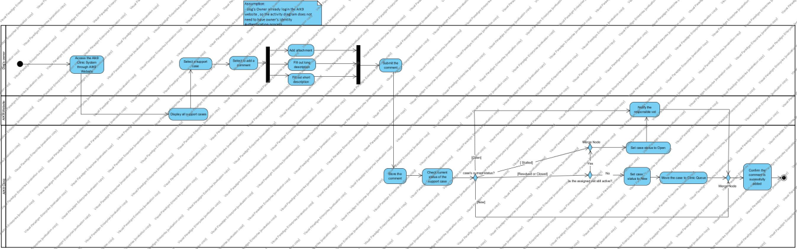

**Question 4: Class Diagram of AIK9 Clinic**

Assumption: Clinic Queue only contains new cases

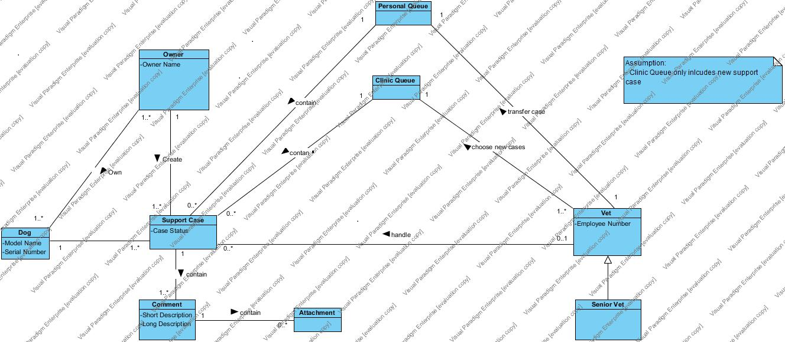

**Question 5:**

**5a. System Sequence Diagram of case transfer process**

Assumption: Vet already login the AIK9 System, so the SSD does not need to have vet identity authentication process.

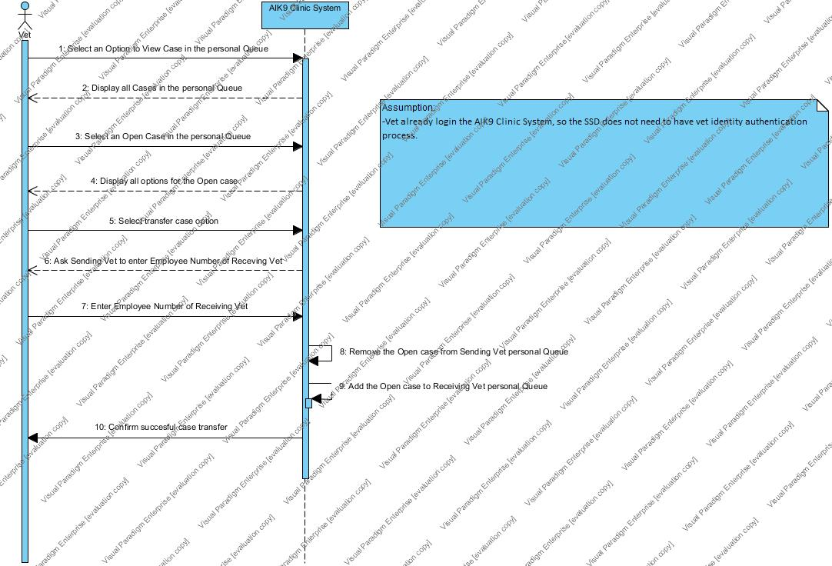

**5b. State Machine Diagram of support case object**

